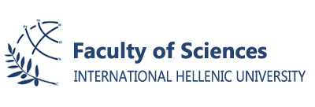

ANNOUNCEMENT

Dear students,

The Faculty of Science, launching a tradition of the Science Collaboration Initiative (SCI), through an international network of collaborations with top universities and research institutes abroad, has created a unique event for you by inviting Professor Angeliki Diane Rigos, who is a Distinguished Executive Director as well as the President of Mass AWIS, Tata Center for Technology and Design, MIT Energy Initiative, to hold an Energy Simulation Seminar / Workshop on October 7, 2019 from 9:00 - 12:30 taking place at the Computer Room (the Computer room is located in cell 22 on the campus map marked up in blue).
It should be noted that the students that will participate (and only them) in the aforementioned workshop will be excluded from that days’ classes (including laboratories) and attendance certificates will be awarded. The seminar/workshop will be for a limited number of students, upon request at despinagkika@gmail.com by 3/10/2019, based on criteria. In case of same scores then first come first serve criteria will be used for the selection of the participants.

